Mounika karampudi.
16158193.

LAB4 DOCUMENT

We have to generate training files of 4 types, by connecting sensor tag to the device and run the connectionservice.java code. The generated files are to be transferred to the cloudera machine using winscp
The below are the training files generated for the punch, right to left and left to right text files.

a)punch text file
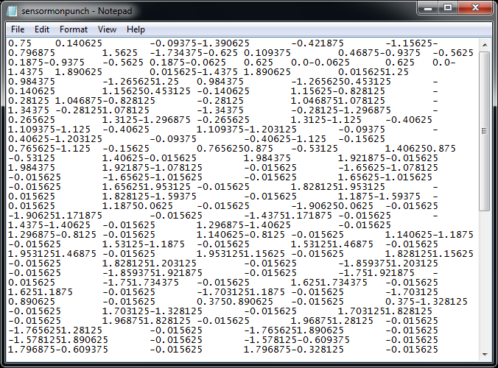
b)left to right text file
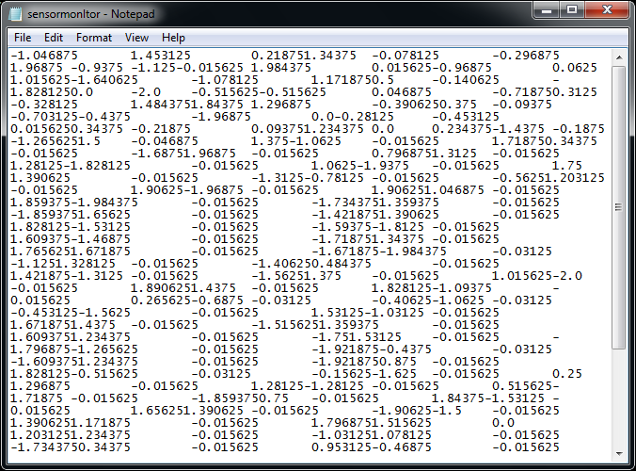
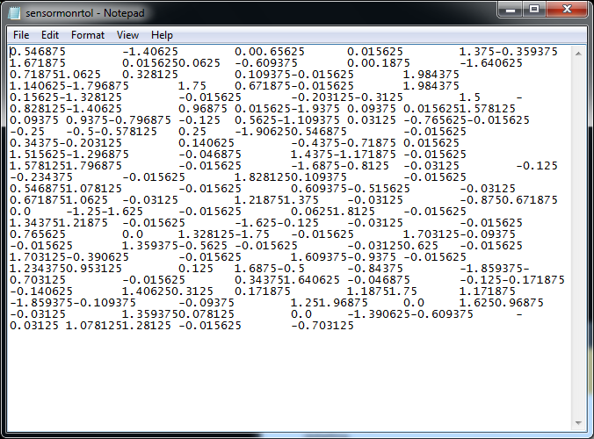
c)right to left text file

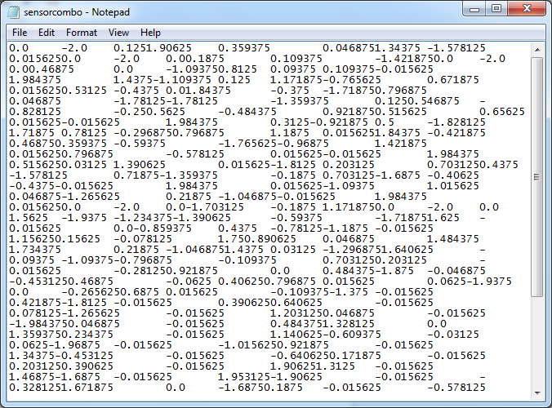
d)Combination test file

Now after training files are generated we have to convert them into sequence files using the path

http://134.193.136.147:8080/HMMWS/jaxrs/generic/TrainFileOperation/-home-group9-sensormonrtol.txt/-home-group9-sensormonrtol1.seq
Input path is: home-group9-sensormonrtol.txt
Output path is: home-group9-sensormonrtol1.seq
a)right to left sequence file
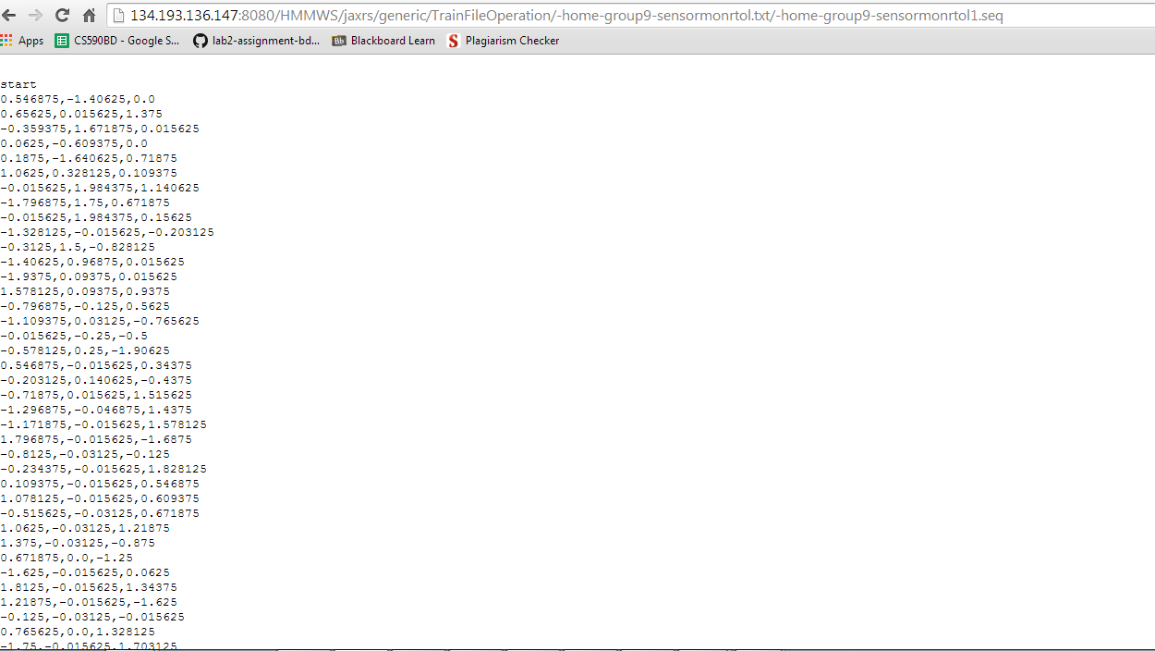

b)left to right sequence file
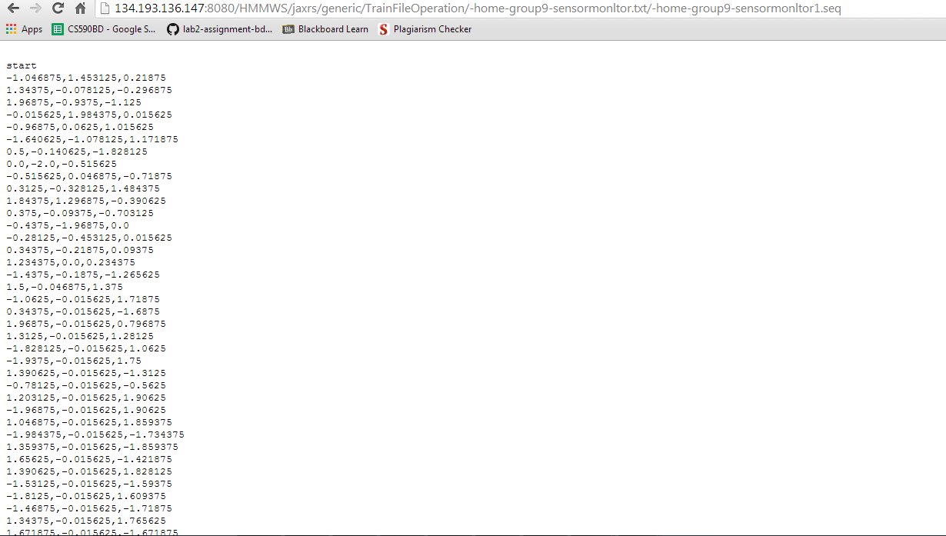
c)punch sequence file

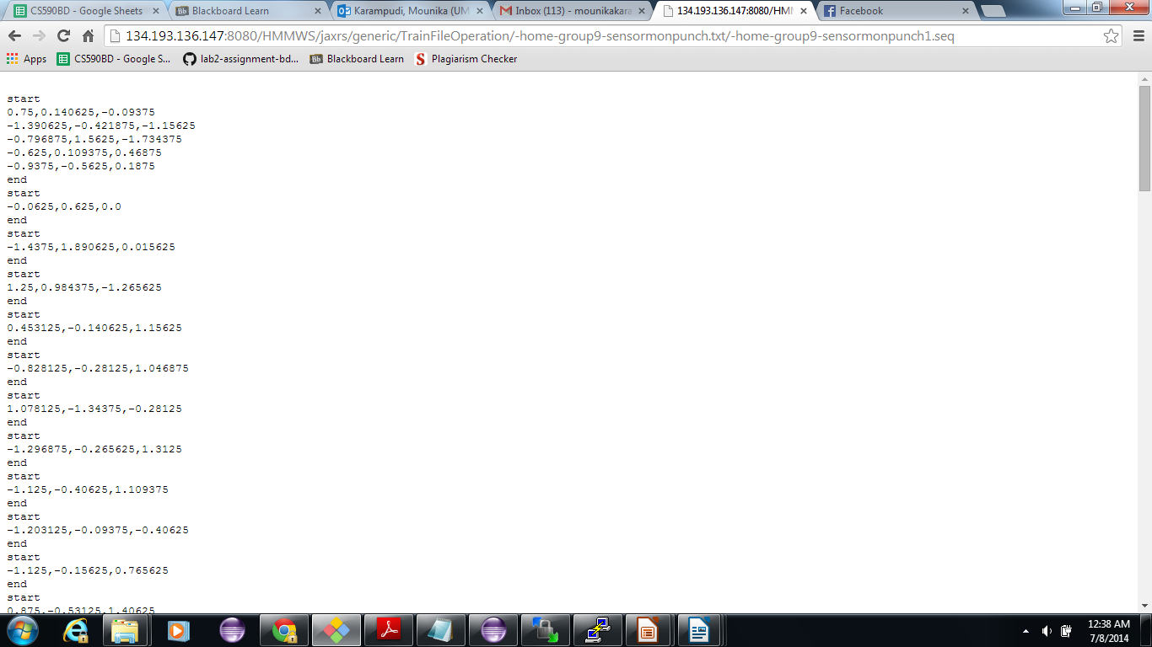

d)combination sequence file

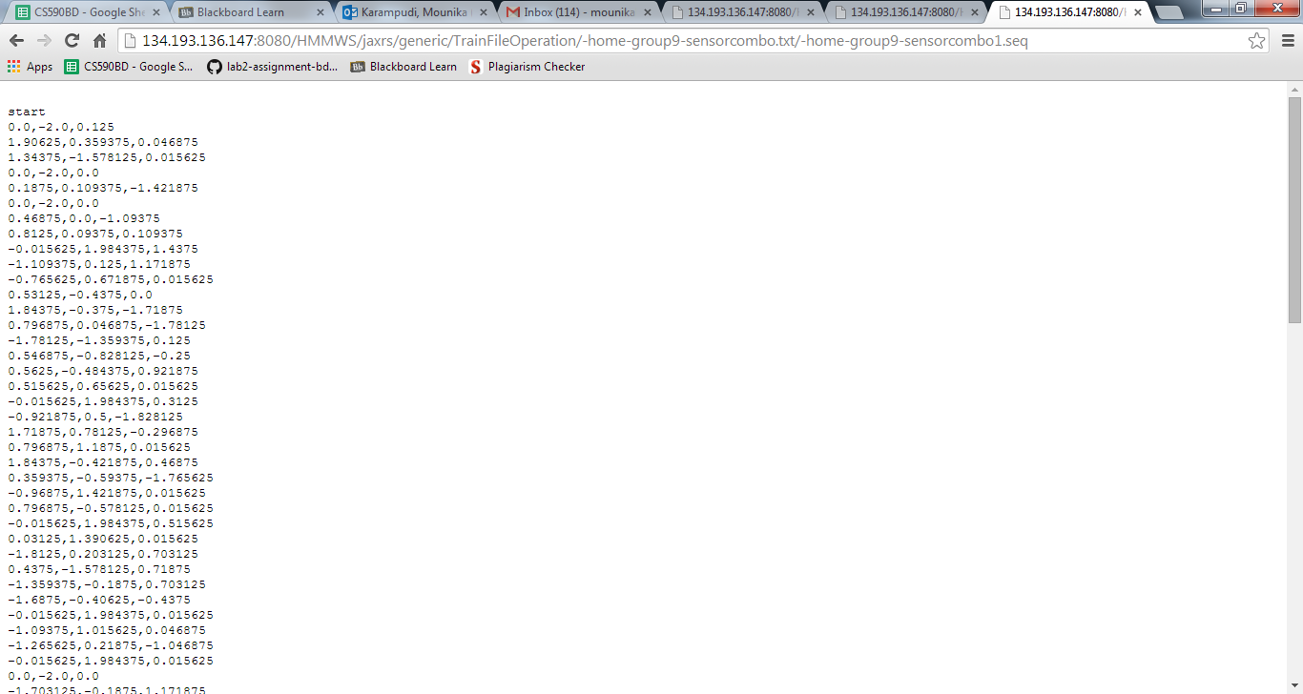

After sequence files are generated, these files are automatically updated into putty as shown below.
